Winter Sem - 2015

To Prof. Lydia Jain

**Software Engineering Project Plan**

Online bookmarking application

**Problem Statement**

With the ever increasing number of websites and use of internet for numerous things, bookmarking important websites have significantly grown. But the present system has limited functionality, one cannot access their saved bookmarks from different computer. Our application will directly address this problem and provide mechanism to organize bookmarks, effectively manage them and the ability to access them from multiple devices.

**Project Objectives**

* Online user account: The application will have user accounts for each of its user, where one registers with the application to get their account.
* Online bookmarks storage: The bookmarks will be stored online instead of local hard drives in the user accounts.
* Bookmarks classification and categorization: Bookmarks can be classified and organized by the user as they want.
* Quick Link Tabs: This will categorise main bookmarks separately for fast and easy access.
* User Interface: All of the process of user registration, bookmark classification will be done on a user interface.

Member work division:

Deepak Choudhary: Bookmark category division design and development.

Om Prakash Chaudhary: User registration/encryption design and development.

Shreyance Jain: Quick link tab and bookmark storage design and development.

**Feasibility Study**

Through online research we found that there doesn’t already exist such a feasible system, this gives the application a complete leverage over the market. And millions of people use bookmarks which gives us big market.

The project execution plan is properly designed considering number of factors in account. Also we have taken additional time frame just in case of unexpected delays.

The application will be quite feasible technically, because it will be an online application which means it just need browser and internet connection to run, it does not depend much on the user system. Operation does not involve much other than timely upgrades.

**Process Model**

Incremental Model:

Rather than delivering the system as a one time delivery, the development and delivery is broken down into increments with each increment delivering part of the required functionality.

The reason we chose incremental model:

* So that we can develop the system in Increments.
* By developing system in increments we will be able to evaluate each increment before proceeding to the development of the next increment.
* By this we can assign each of the member with work in increments wise.

**Deliverables**

* Online bookmarks storage.
* User account to manage and store bookmarks.
* Bookmarks classification and organization.
* Accessibility from multiple computers enabled with browser and internet.

We plan to use Windows platform and framework.

**Project Scheduling**

|  |  |  |  |  |  |
| --- | --- | --- | --- | --- | --- |
| **Milestone** | **Estimated Start Date** | **Estimated Completion Date** | **Estimated Hours** | **Number of Resources** | **Number of Days** |
| **Software Requirements Specification** | **1/19/2015** | **2/1/2015** | **35** | **3** | **9** |
| **Software Design** | **2/2/2015** | **2/15/2015** | **35** | **3** | **9** |
| **Detailed Design** | **2/16/2015** | **3/8/2015** | **60** | **3** | **19** |
| **Coding** | **3/9/2015** | **4/5/2015** | **120** | **3** | **26** |
| **Unit Testing** | **4/6/2015** | **4/12/2015** | **20** | **3** | **5** |
| **Integration Testing** | **4/13/2015** | **4/19/2015** | **20** | **3** | **5** |
| **System Testing** | **4/20/2015** | **4/26/2015** | **20** | **3** | **5** |
| **Project Demo** | **4/27/2015** | **4/27/2015** | **3** | **3** | **1** |
| **Total Hours** | | | **313** | | |

**Gantt chart:**

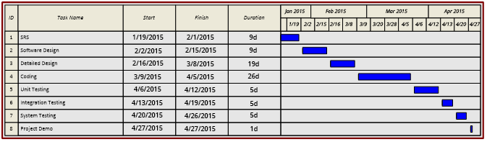

**Pert chart:**

